Regression Project Fall 2012

Please print your name in this box:

Instructions: Please collect at least 100 paired observations (not independent samples). Show all work and answers on this sheet. Please do not write “see attached sheets,” for that will be futile. Following instructions is part of the grade. Due date: The start of class for Test III.

- What is your regressor (x variable)?  What is your response (y variable)? | - Why did you choose this specific variable to be your response?
- Test your response variable for normality. Insert your normality plot in this box (you will have to shrink it). Report the p value in your conclusion to this test.  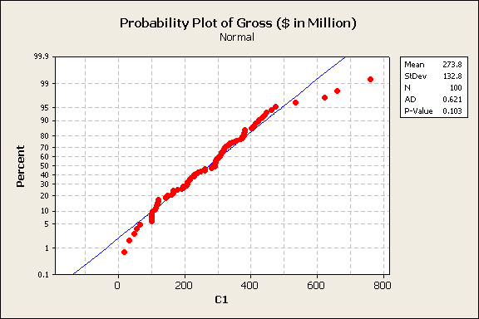 | - Please report these summary statistics for your response variable:
  Mean | Median | St. dev.
  Range | Avg x | Avg y
  Variance | Skewness and interval for skewness | Kurtosis and interval for kurtosis
  N (# pairs) | Sum (x) | Sum(y)
  Sum (xy) | Sum(x²) | Sum(y²)
- Use the summary calculations in question 4 to compute the slope coefficient m and the intercept b (show your steps). | - Interpret your slope coefficient as an elasticity.
7.

EV | UV | TV | R² | r

8. In this box please paste your scatterplot, with the regression line included (you will have to shrink the graph).  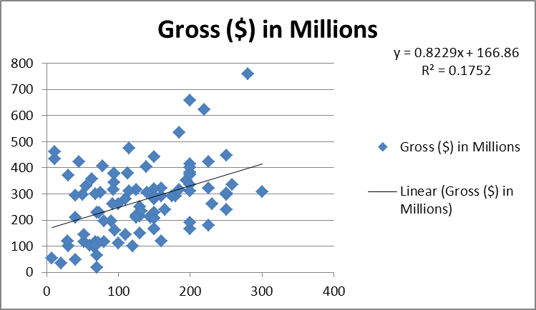 | 9. In this box please paste your residuals plot (you will have to shrink it). What assumption is being tested with the residuals plot?  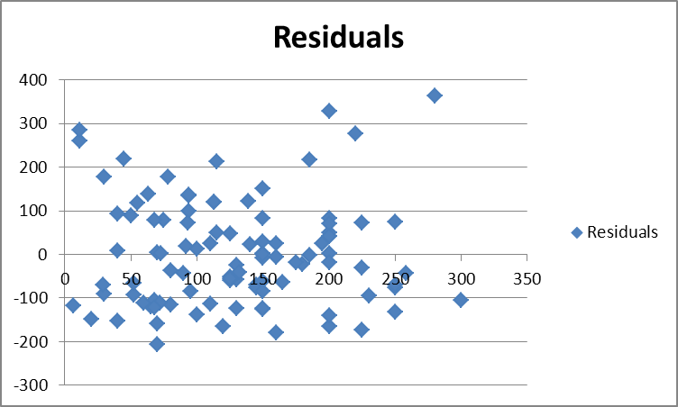
10. Please produce your Regression ANOVA table here:

11. Please compute a confidence interval for the true population slope coefficient:

m | S | Sqrt(Σ(x – )²) | t_{n-2} | interval

12. Please test for the significance of the correlation coefficient. | 13. Please record three sensible predictions (answers will vary, depending on your data):
  Regressor (x) | Response (y)
14. On the top of p. 556 in your book is the formula for the prediction interval for y hat. Please choose a sensible value for x, then report your prediction interval:

t | S | Square root
Product | Interval

Please work these problems from the book:

- p. 534 # 10 | - p. 535 # 30
- p. 550 # 23 | - p. 550 # 30
- p. 558 # 16 | p. 558 # 13

Chapter Quick Quiz (chapter 10, p. 576)

1.

2.

3.

4.

5.

6.

7.

8.

9.

10.

